Case-Study-–-EC2-EBS-EFS
Step 1: Created an instance with Linux OS in us-east-1(Virginia) region
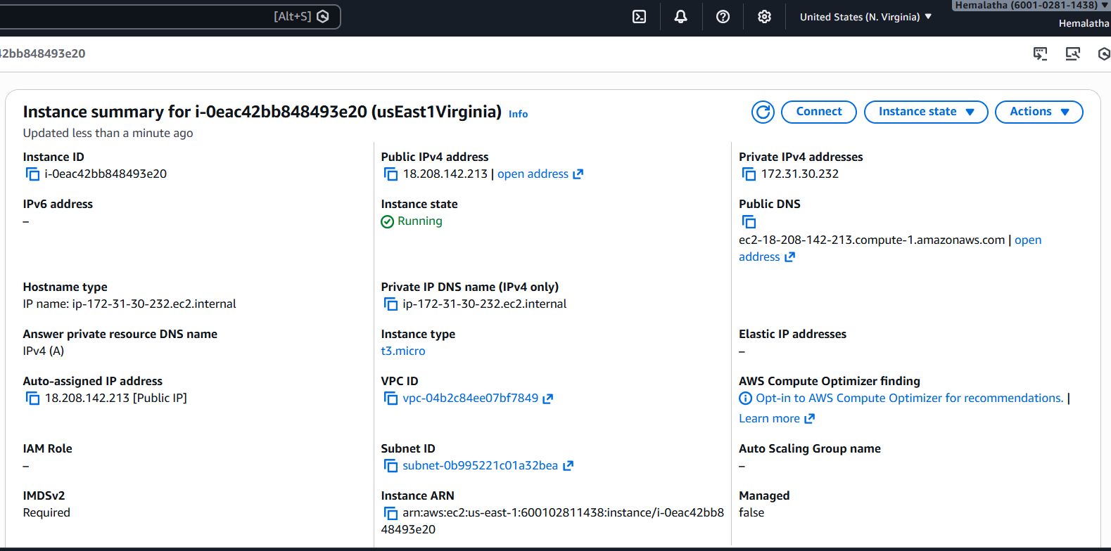
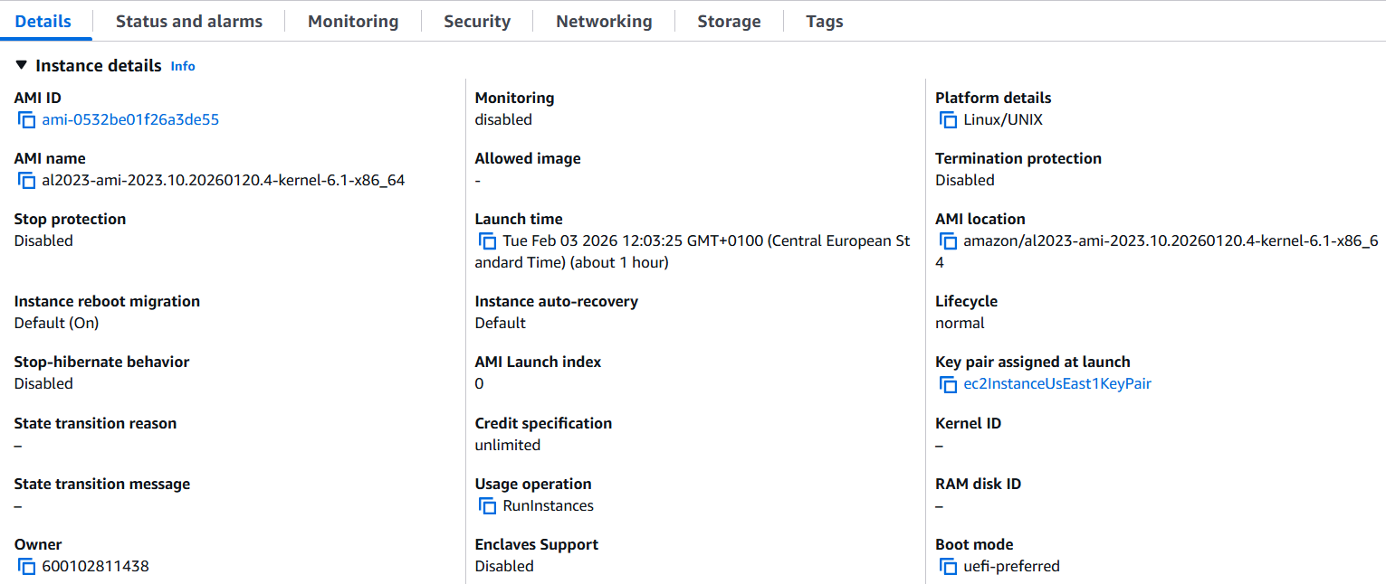

It has security group that allows HTTPS traffic.

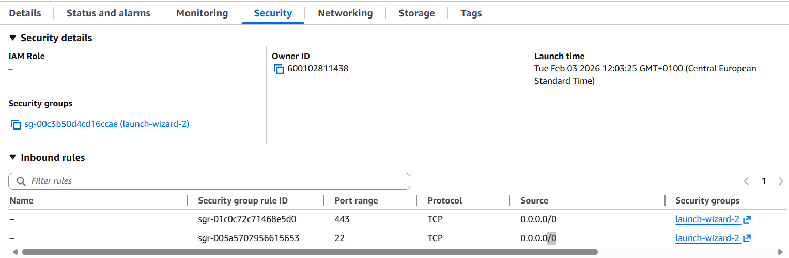

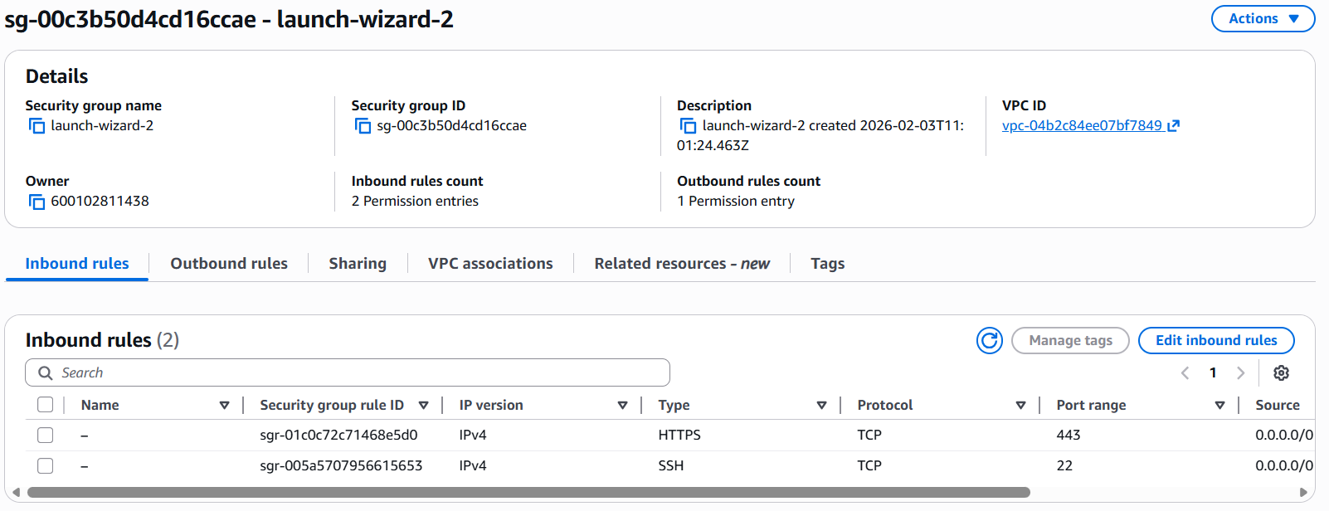

Step 2 – Replicate the instance in the US-West-2 (Oregon) region.
Created an AMI from instance in us-east-1 Virginia region.

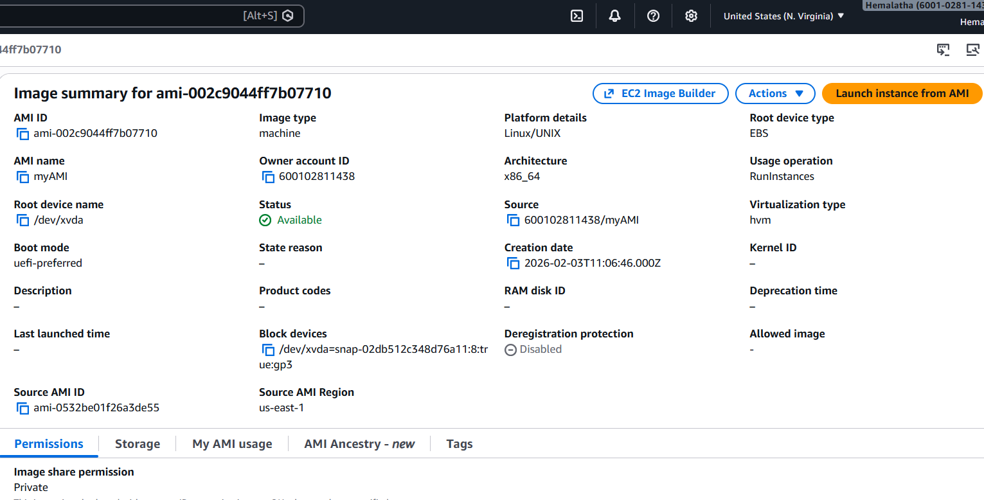
Copied that AMI into us-west-2 Oregan region.

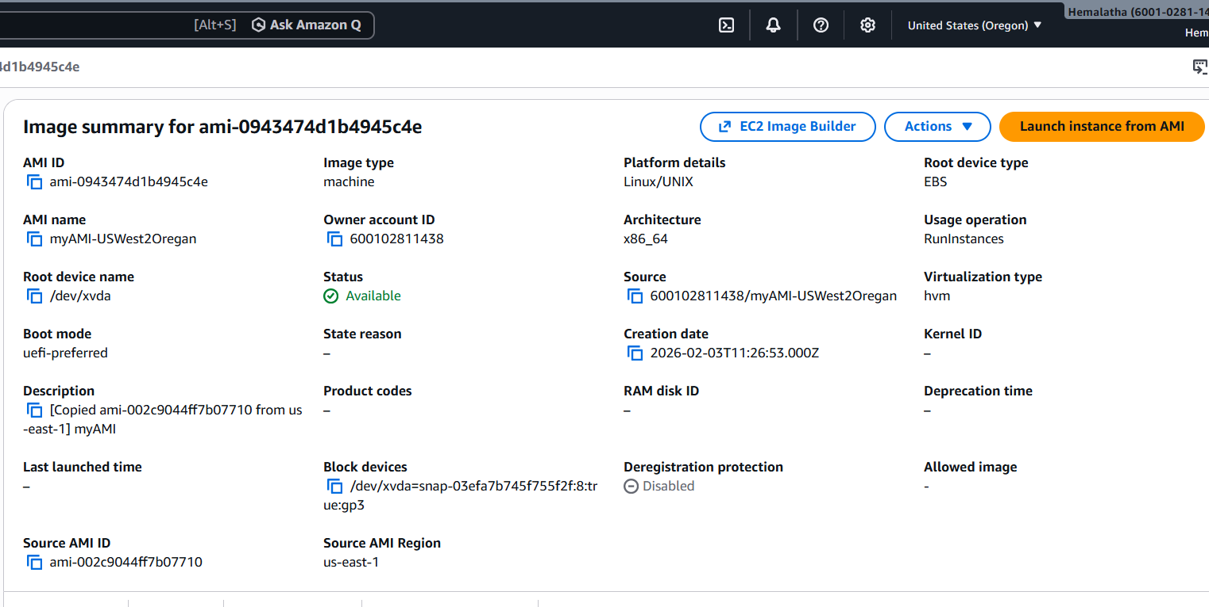

Launched instance from AMI in us-west-2 Oregan region.

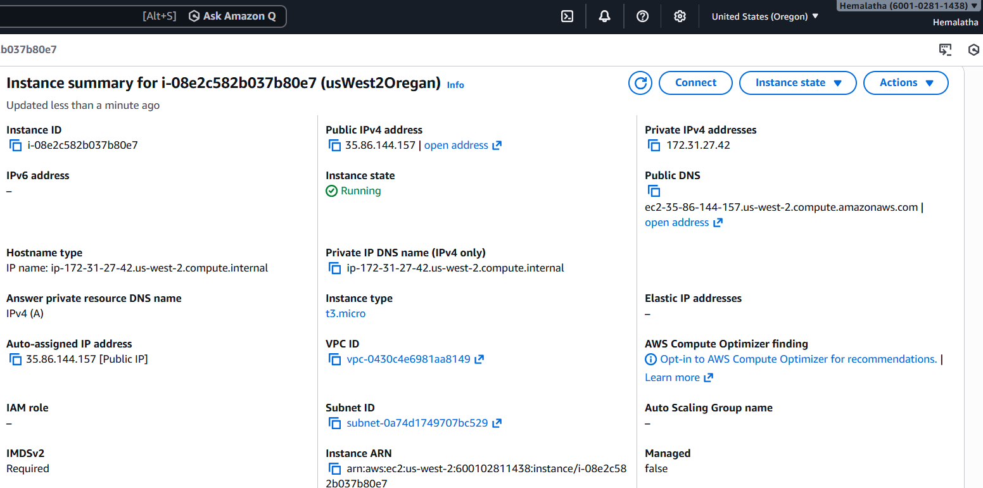
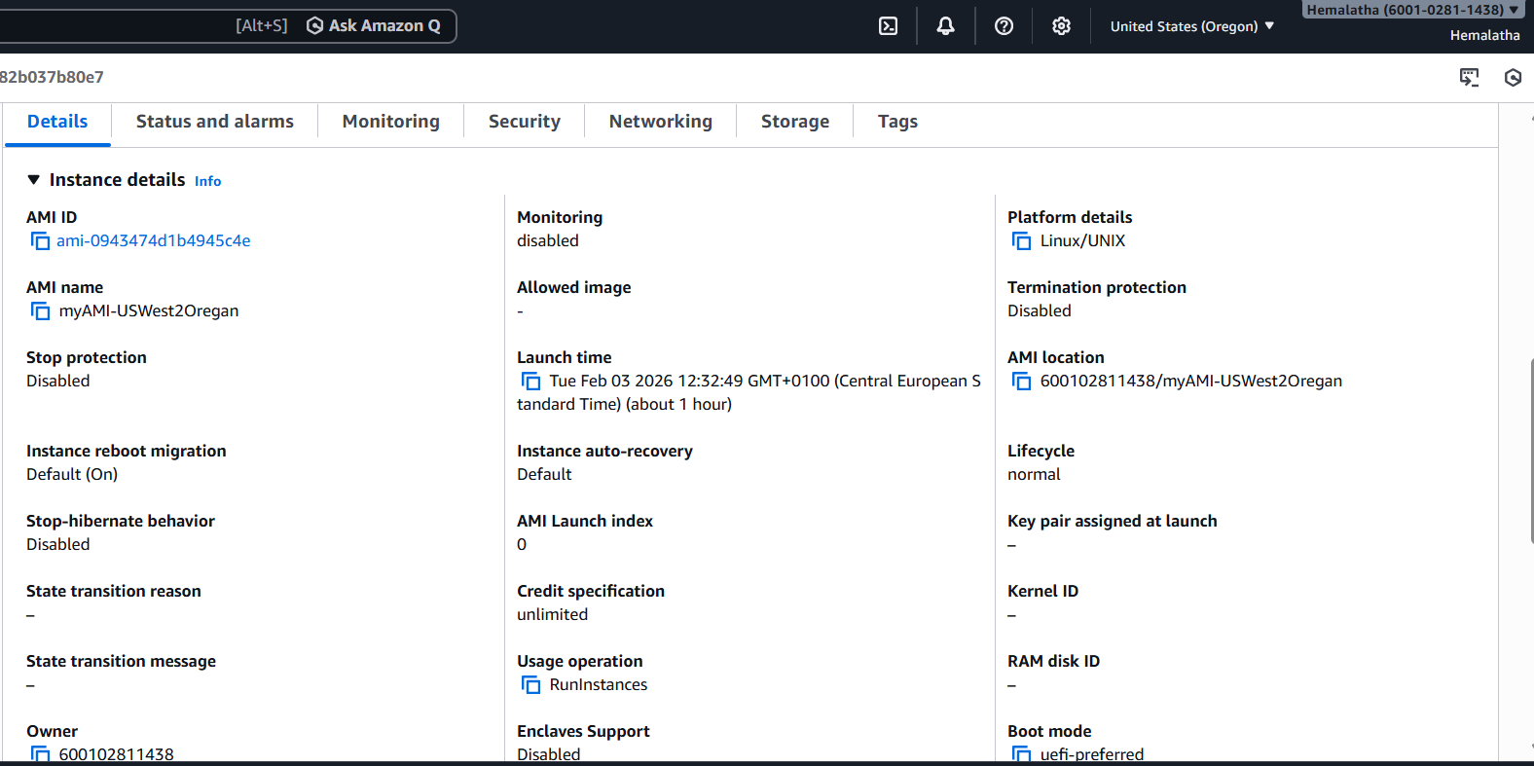

Step 3 - Build two EBS volumes and attach them to the instance in the US-East-1
(N. Virginia) region.
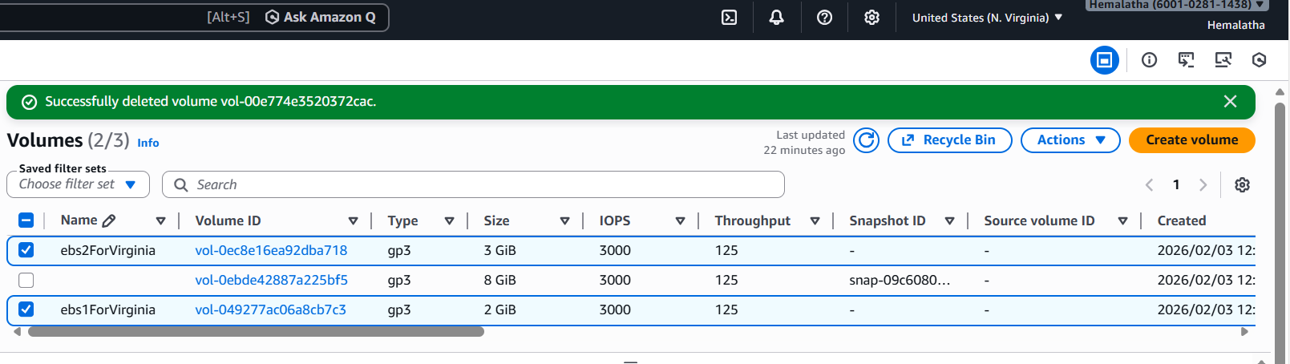
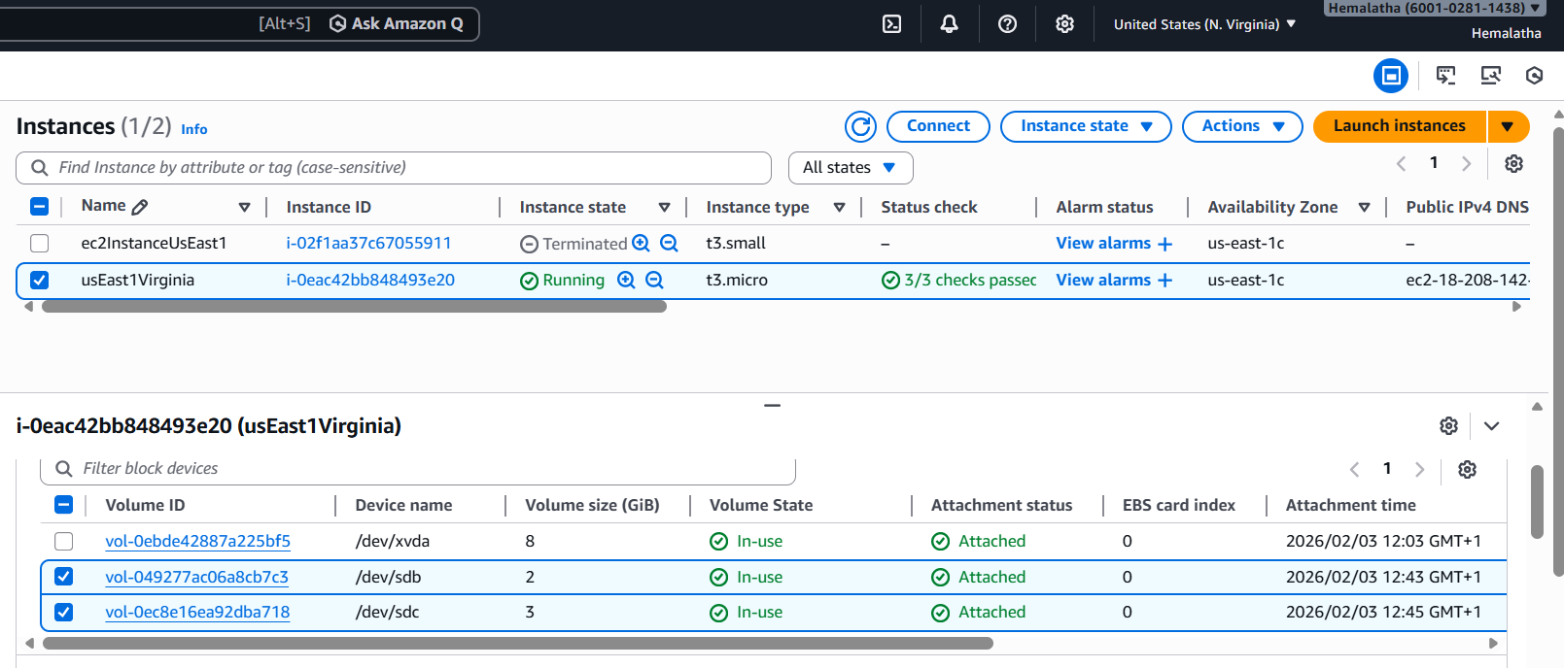
Step 4 - Delete one volume after detaching it and extend the size of the other
volume.
Detached one volume
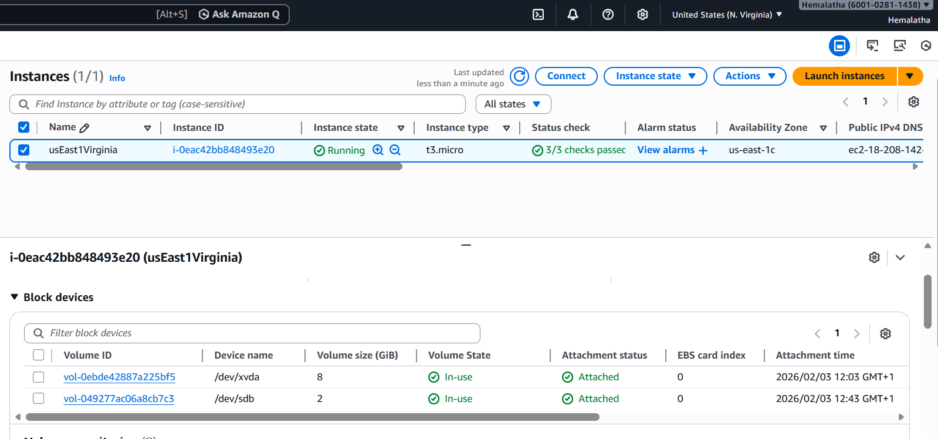
Delete one volume after detaching it.
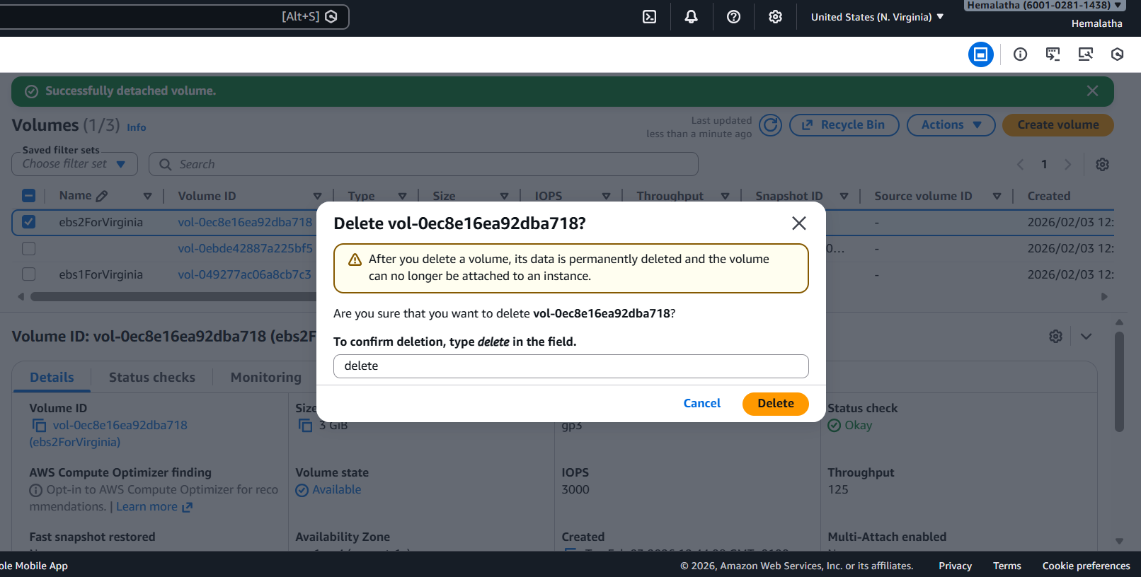

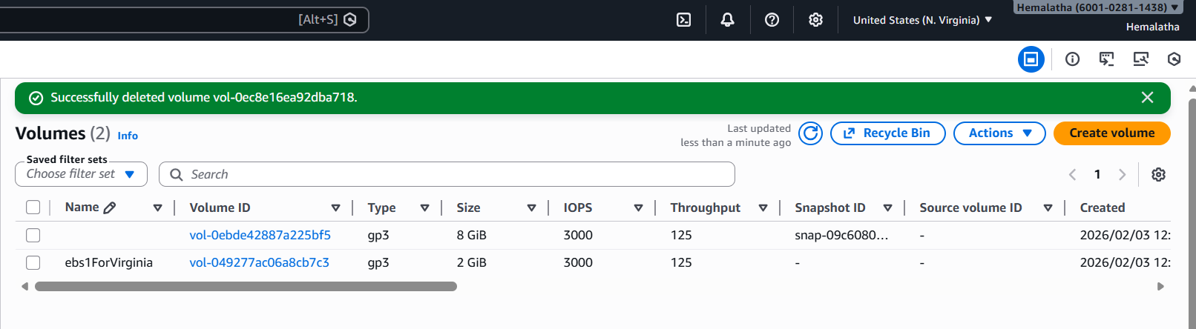

Extend volume size
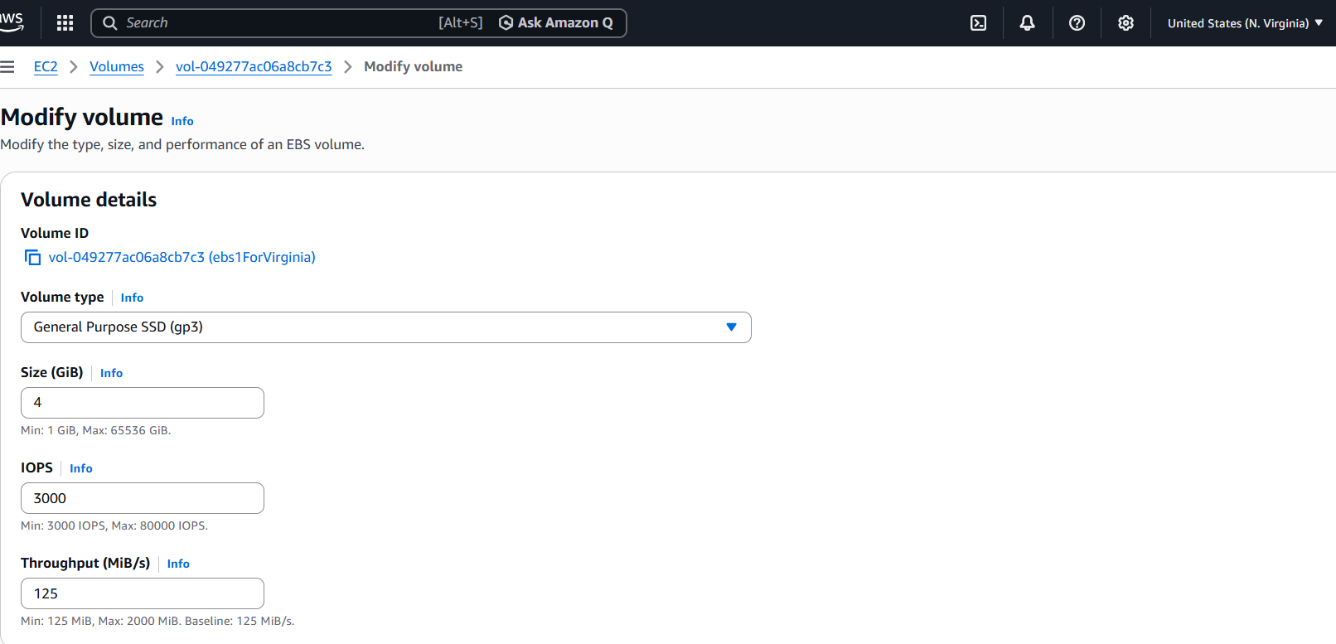

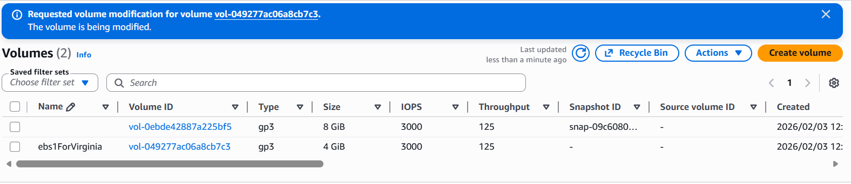

Created a snapshot

